|  |  |
| --- | --- |
| Arduino Uno | Arduino Mega |
| The Arduino Uno is a microcontroller board based on the ATmega328 (datasheet). It has 14 digital input/output pins (of which 6 can be used as PWM outputs), 6 analog inputs, a 16 MHz ceramic resonator, a USB connection, a power jack, an ICSP header, and a reset button. The Uno differs from all preceding boards in that it does not use the FTDI USB-to-serial driver chip. Instead, it features the Atmega16U2 (Atmega8U2 up to version R2) programmed as a USB-to-serial converter. | The Arduino Mega 2560 is a microcontroller board based on the ATmega2560 (datasheet). It has 54 digital input/output pins (of which 15 can be used as PWM outputs), 16 analog inputs, 4 UARTs (hardware serial ports), a 16 MHz crystal oscillator, a USB connection, a power jack, an ICSP header, and a reset button. The Mega is compatible with most shields designed for the Arduino Duemilanove or Diecimila. The Mega 2560 is an update to the Arduino Mega, which it replaces. |

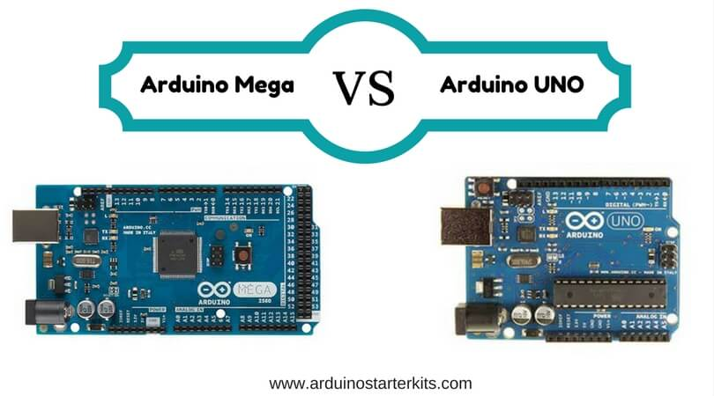

|  | [**Arduino Mega**](https://www.amazon.com/Arduino-Compatible-Atmega2560-Mega2560-Board/dp/B00JTBMD7E/?tag=arduinostarterkits-20) | [**Arduino UNO**](https://www.amazon.com/Arduino-Board-Module-ATmega328P-Blue/dp/B008GRTSV6/?_encoding=UTF8&tag=arduinostarterkits-20) |
| --- | --- | --- |
| **Voltage** | 5V | 5V |
| **Digital I/O** | 54 | 14 |
| **Analog Inputs** | 16 | 6 |
| **UART** | 4 | 1 |
| **Speed** | 16MHz | 16MHz |
| **PWM** | 14 | 6 |
| **Programming Interface** | USB via ATMega16U2 | USB via ATMega16U2 |

***Software and Hardware Review***

***UNO AND MEGA***

The Arduino Mega 2560 is featured with four UARTs (hardware ports), means you will get the top speed through multiple ports. The UNO provides the same through its NewSoftSerial library software. But as the software connection may be a bit slower, so if your design is pushing limits at maximum level, then it is recommended that you use Mega 2560 board. I.e. you can use the primary port for debugging and the secondary port for the communication.

***Main difference***

The Pulse Width Modulation is a key difference between the both. Use of PWM cuts down the need for a motor with a varied voltage which is not ideal for a controller. Still, you can use PWM with the 6 pins and some extra coding on UNO, but having 14 pins on Mega gives more steady voltage during the partial power on and off situations.